Analysis of Stocks Assignment

Name: Pratap S

Reg Number: 22BCE9334

Slot: F1

Technique 1:

1. **Descriptive Statistics**:
   * Calculate basic statistics such as mean, median, standard deviation, skewness, and kurtosis to understand the distribution and characteristics of the data.
2. Converted to normal excel to excel.csv(Comma Separated Values).
3. I used Jupyter notebook to compute the descriptive Statistics for the following data.
4. First, all the required libraries were imported. 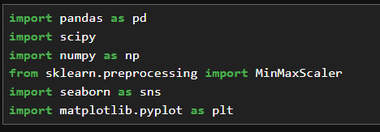
5. The required file has to be imported to the jupyter notebook. 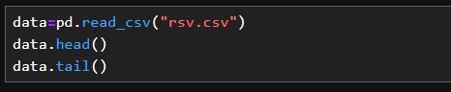  
     
   Output:  
   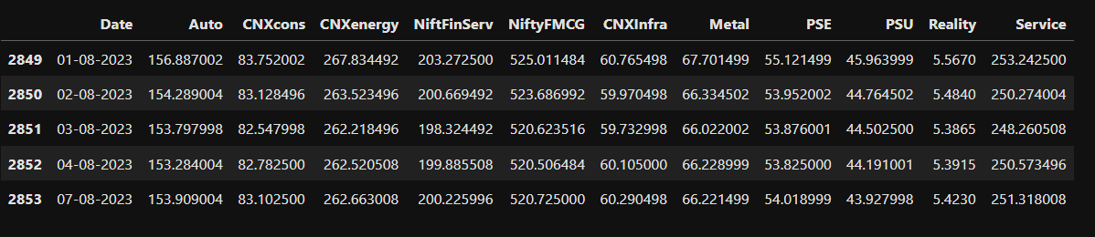
6. Pre-processing of data contains several steps which include:

Checking the number of columns, data types of columns and total number of entries( data).

These are found using the command .info() in python.

  
  
Output:  
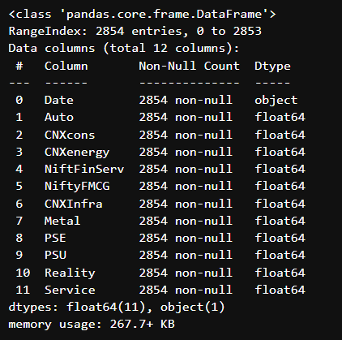

Checking whether any of the data are having null values which would result in the inaccurate results for the analysis. If any null values are present, the data is filled using the data that is present in the previous date. That is inserted into the null value space. This can be checked using the .isnull().sum() function in python.

  
  
Output:  
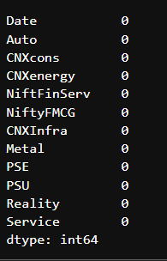

1. Now the characteristics of the data are found using the function .describe() in python.  
   This function includes count, mean, Standard Deviation, Minimum value, Maximum value, and others.  
     
     
   Output:  
   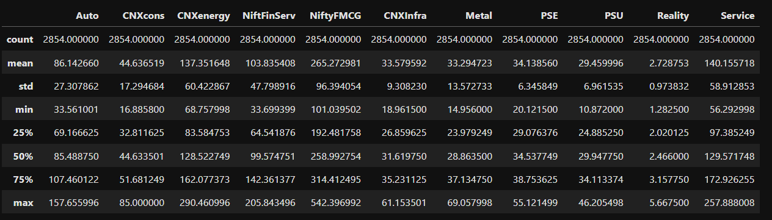
2. As per the question requirement, Skewness of the data can be found using the following code.  
     
   or  
   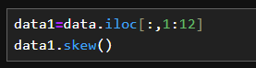  
     
   Output:  
   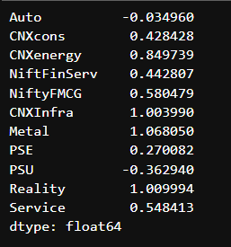  
     
   The Meaning and its significance is mentioned below in the image.  
   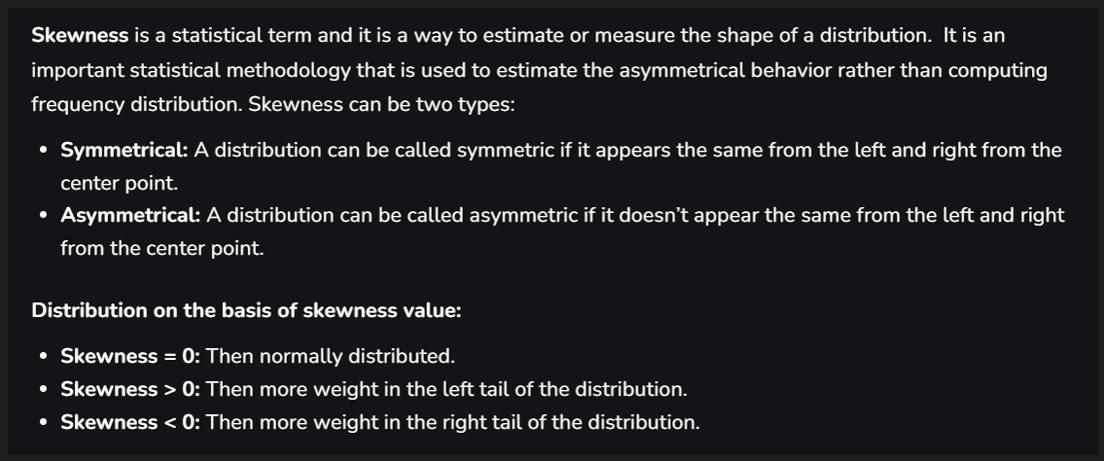
3. The kurtosis of the data is also found using the below code.  
     
     
   Output:  
   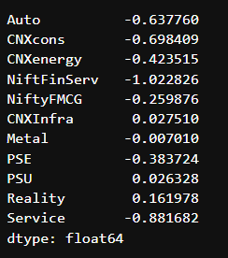  
     
   The Meaning and its significance is mentioned below in the image.  
   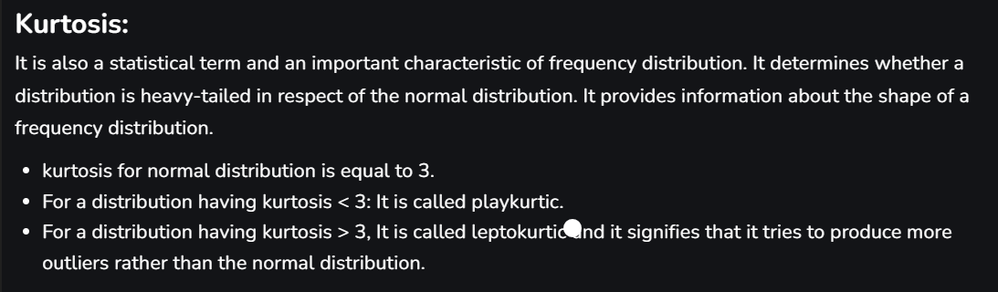
4. For better understanding of the stocks, a line plot is plotted using all the given stocks in the data.  
   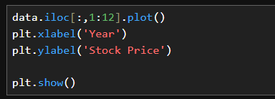  
     
   Output:  
   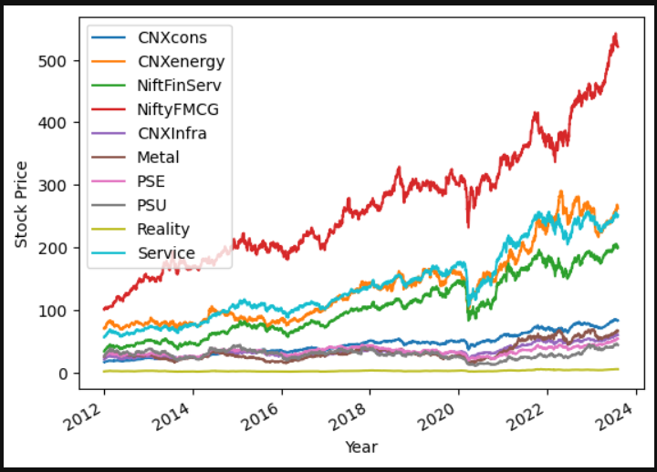

The above assignment is also available in my Github profile which is directed using the following link:  
<https://github.com/pratap834/stock_predict0r.git>